**60760 F1 + F3**

A few month ago, I replaced the decoder of my Märklin 120 003-9 (3653) with the 60760 decoder and 5-pole HLA motor.  
  
The simple 60760 decoder officially supports only the standard light ports (LV / LR) but no additional free AUX ports. But there are two undocumented AUX ports available. F3 is an amplified AUX port that can be connected directly, F1 is a non-amplified logic level port, that must be amplified before using.  
  
For the beginning, I connected a control cab light to F3. On the right side, You can see the buffer capacitor:  
  
[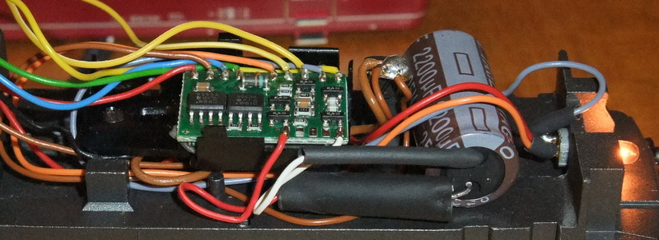](http://up.picr.de/19675511ua.jpg)  
  
To enable the non-amplified F1, You can take a lokk to this document:  
[http://www.web-hgh.de/pp...l/Decoder-Tuning_pic.pdf](http://www.web-hgh.de/ppt-dl/Decoder-Tuning_pic.pdf)  
  
or to my circuit plan, including the buffer capacitor with resistor and Schottky Diode:  
  
[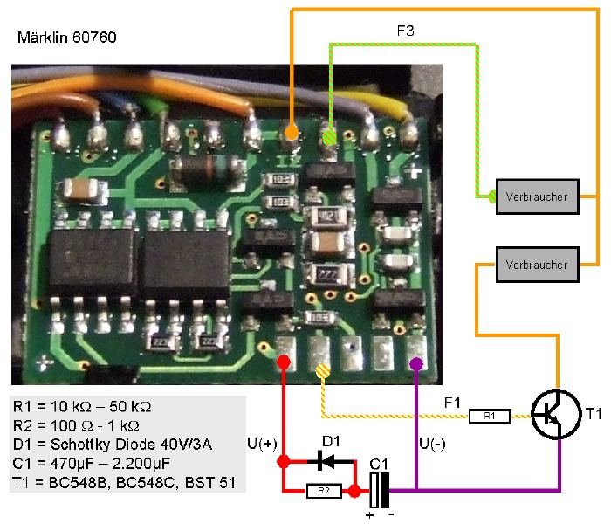](http://imageshack.com/scaled/800x600/407/cwrr.png)

Here the motor shield equipped with ball bearing:[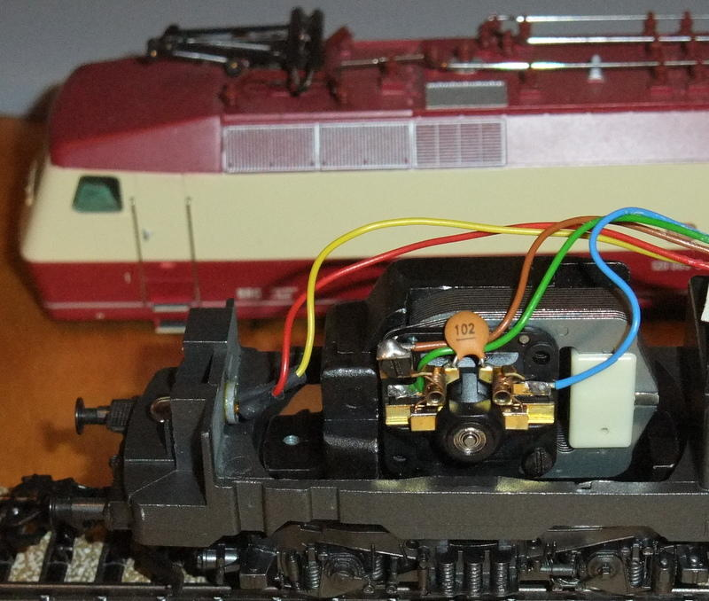](http://up.picr.de/19675512sa.jpg)  
  
And here the control cab with interior light (much to bright):  
  
[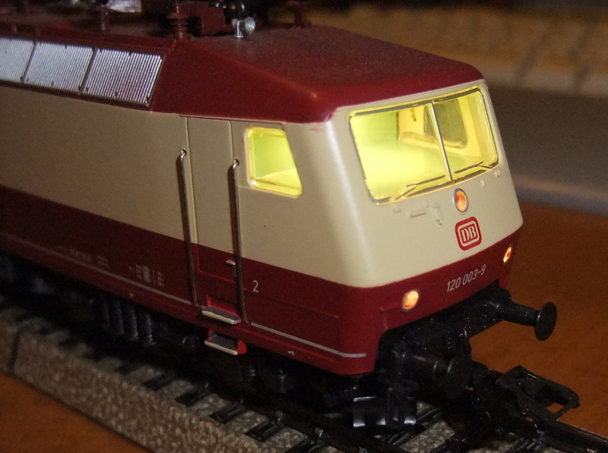](http://up.picr.de/19675513jo.jpg)  
  
[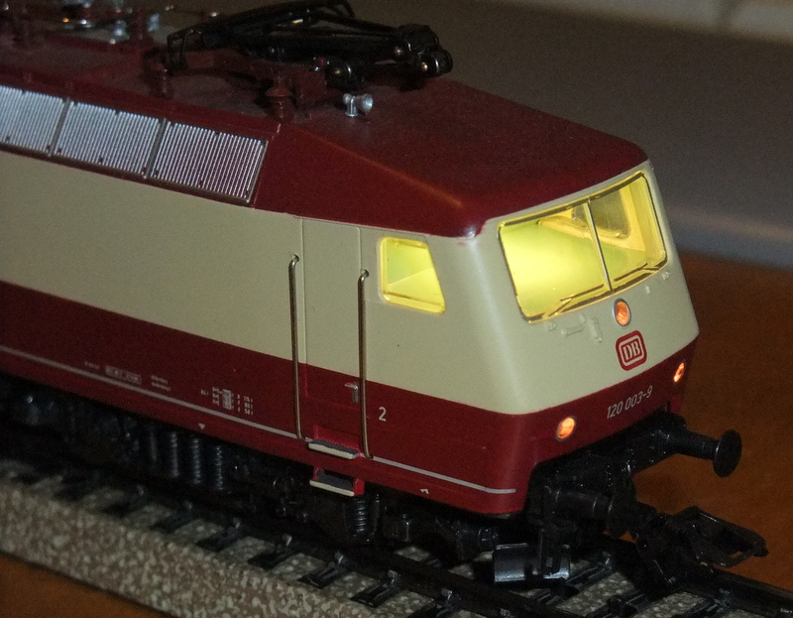](http://up.picr.de/19675514cy.jpg)

[*Edited by user*](https://www.marklin-users.net/forum/posts/t32114-Marklin-BR-120--3653----60760-HLA-conversion---Ball-Bearings---Buffer-Capacitor--F1-and-F3-enabled)*09 October 2014 06:51:29(UTC)  | Reason: Not specified*

**Enable F1 AUX port on 60760 fx decoder**  
  
These are the needed parts to enable the un-amplified F1 AUX port:  
  
[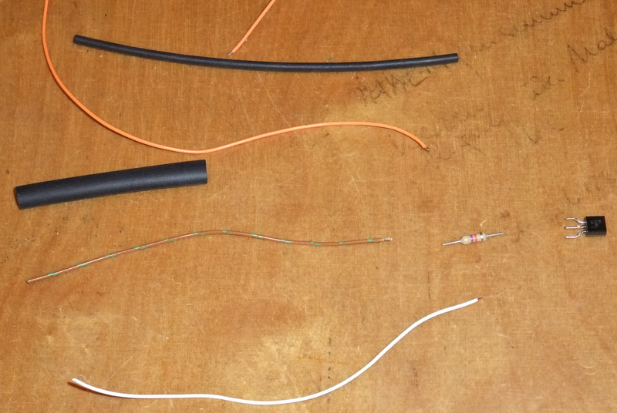](http://up.picr.de/19758758gs.jpg)  
  
The transistor and capacitor are soldered with the cables and put into the shrink hose:  
  
[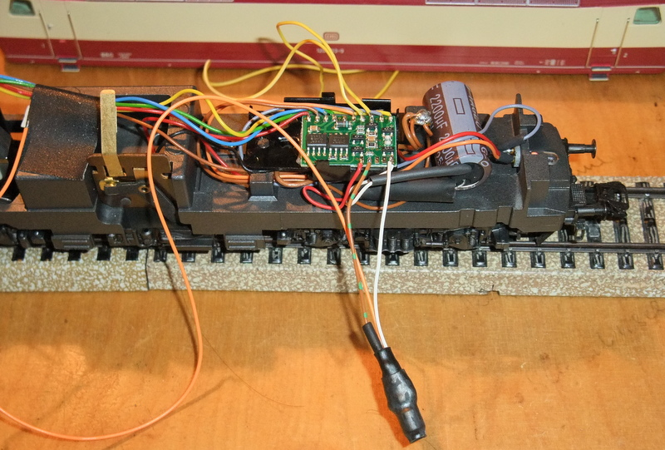](http://up.picr.de/19758726hx.jpg)  
  
The white cable is the decoder GND (in the circuit plan it is purple) and the brown-green one is connected to the low-level F1 AUX port:  
  
[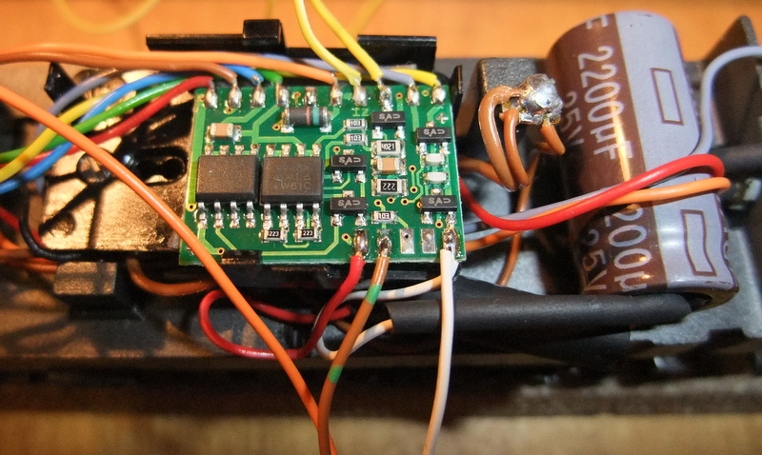](http://up.picr.de/19758727fi.jpg)  
  
The orange one is ready to be connected to an electrical load (light bulb, LED, ...):  
  
[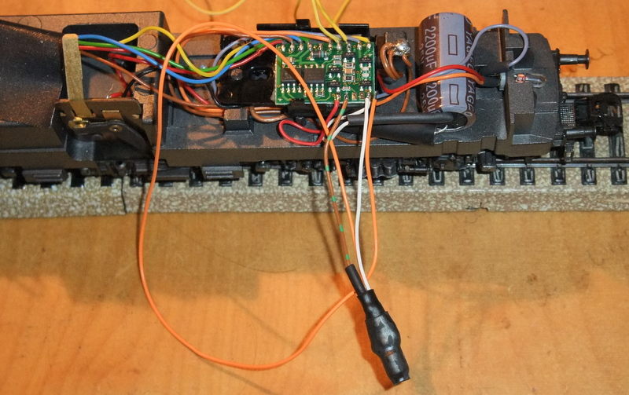](http://up.picr.de/19758728xa.jpg)  
  
There is no function mapping needed, the AUX port is already mapped to F1. On the MS2 You only have to activate the F1 button!

voici une modif du decodeur 60760  
  
avec d'autre transistor voir meme deux transistor  
  
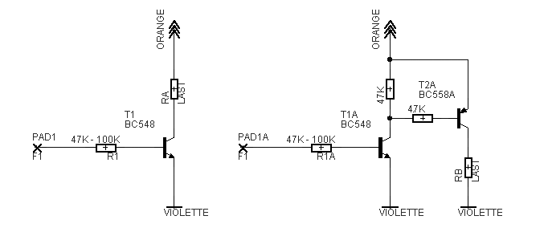  
  
  
Bonne journee  
  
Frederic