|  |
| --- |
| On 9. nov. 2022, Bernhard Watkins wrote a response to my question about how to shorten C-track.  "I have shortened a Lot of C Track.  1) At a convenient point remove the excess Road Bed and Pukos preferably close to one end of the Donor Track. Do not cut the Rails.  2) Slide the Short end along the Rails to meet the Main Part.  3) Glue and secure.  4) Remove excess over Hanging Track.  5) Wire the two ends of the New Track to each other to re-establish Electrical Continuity.  You now have a Shortened Track Section with Original Ends and Connections and because you left the Rails un-cut it is Stronger.  Bernhard"  Bernhard's procedure was very logical, and I needed to create a shorter section. I decided to use a piece of 24064 as a test, also because I needed a piece about 2.0 cm shorter. |

24064 showing possible cut lines

The first step was to establish where to cut through the roadbed. I wanted the final result to have the same spacing between the ties at the cut location. I cut between the ties, also careful to avoid cutting any of the metal connecting system.

Initially, I cut through the plastic roadbed as much as possible to establish the cut lines. I used a miniature table saw, but a fine hand saw would work as well.

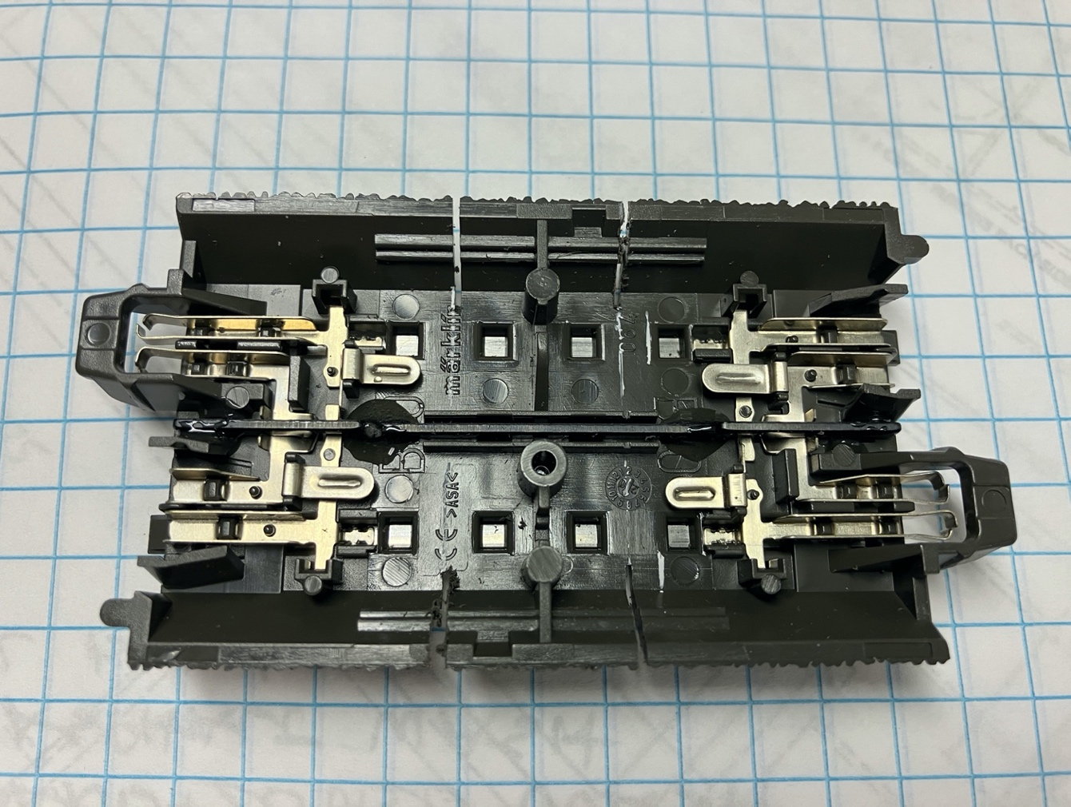

First cuts

24064 first cuts in sides of roadbed

In order to cut through the plastic under and between the rails, I needed to cut through the center rail to make a gap for the saw. Before I did this, I mixed some epoxy and glued the two end pieces of the center rail to the plastic roadbed. This was also a good time to mark one section as "Moving" with an "M," and to use AC to glue the rails to the chairs of the Fixed section.

With all the glue set, I cut through the center rail with a Dremel disc in a flexible shaft.

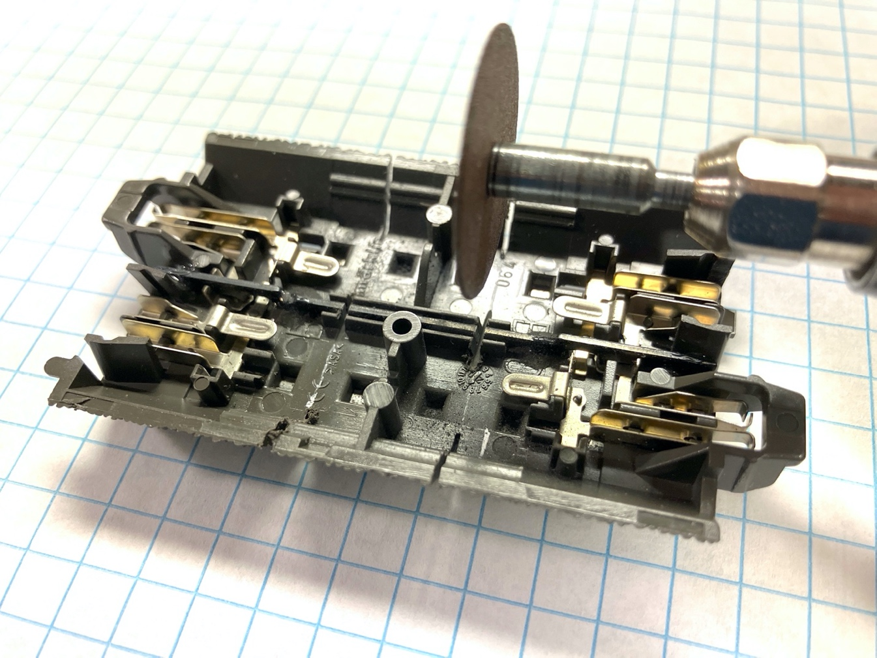

Cuting the center rail with a Dremel disc along same lines provides a gap for cutting the plastic.

Then I finished cutting through the plastic roadbed. Last, I removed the chairs by hand with an Exacto fine saw blade.

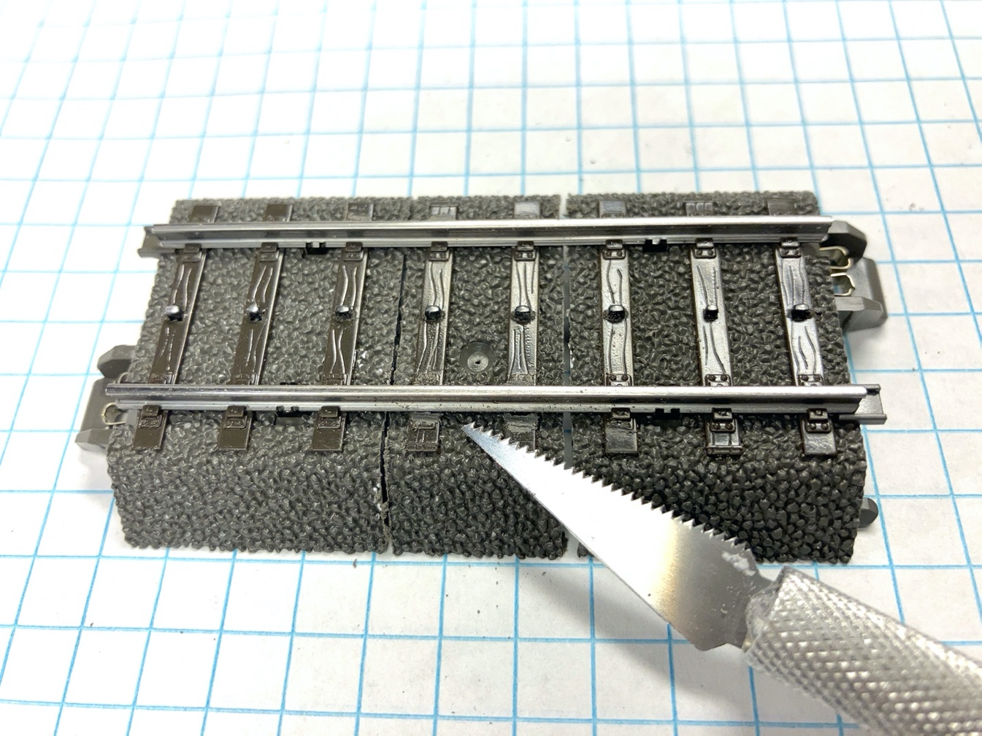

Cut all the way through plastic, using gaps in center rail. Remove tie clips (chairs) to rails.

With all connections to the rails removed, the center section was free.

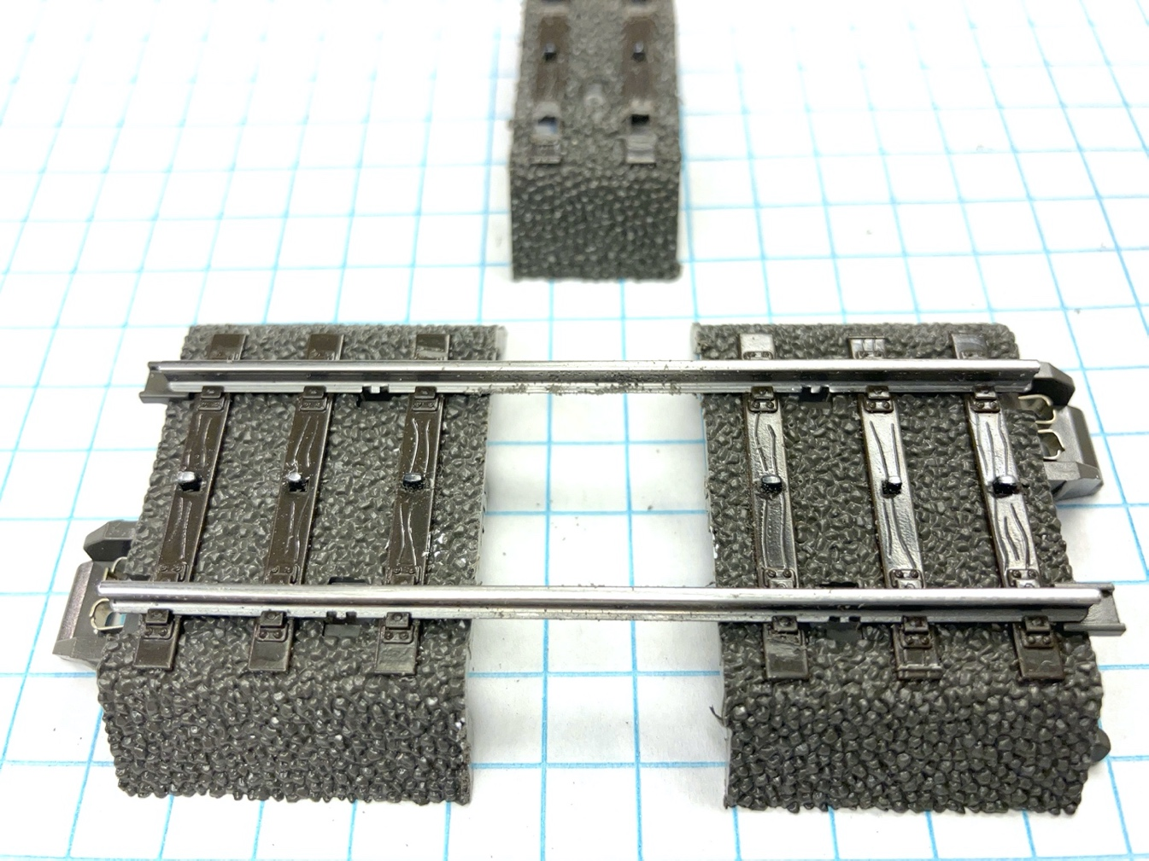

The next operation was harder. There are two tiny spring clips on each rail that contact the rail from underneath. They each fit into two small cuts in the bottom flange of the rail, between the second and third tie (sleeper). These clips were holding the Moving section in place, so they had to be removed.

I tried several different tools, but it didn't seem that there was any good way to grab these clips and bend them away from the rails, and I didn't want to damage the metal attachment system, so I used a dental drill in the Dremel to cut through the clips where they met the rail.

This operation also cut into the flange of the rail, but that wasn't a problem because when the Moving section was slid up to the Fixed section, the protruding rails would be cut off behind the area where the flange was cut.

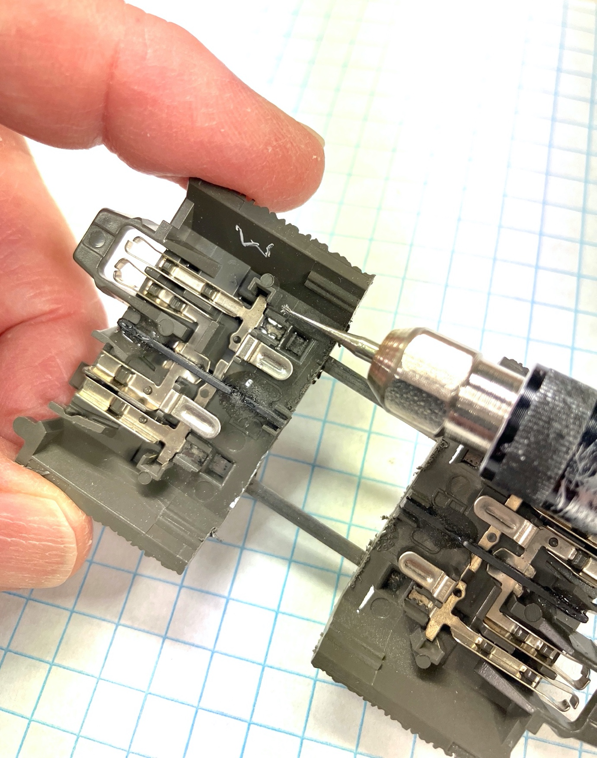

Cutting through the tabs with a dental drill, on the moving section "M"

I used three different drills, a sharp-edged one, a round one, and a longer serrated one. Then I probed into the gaps and pushed the remaining clip pieces away from the rails with a pin.

This operation left some burrs on the underside of the rail, so I used the round bit again to smooth off the burrs.

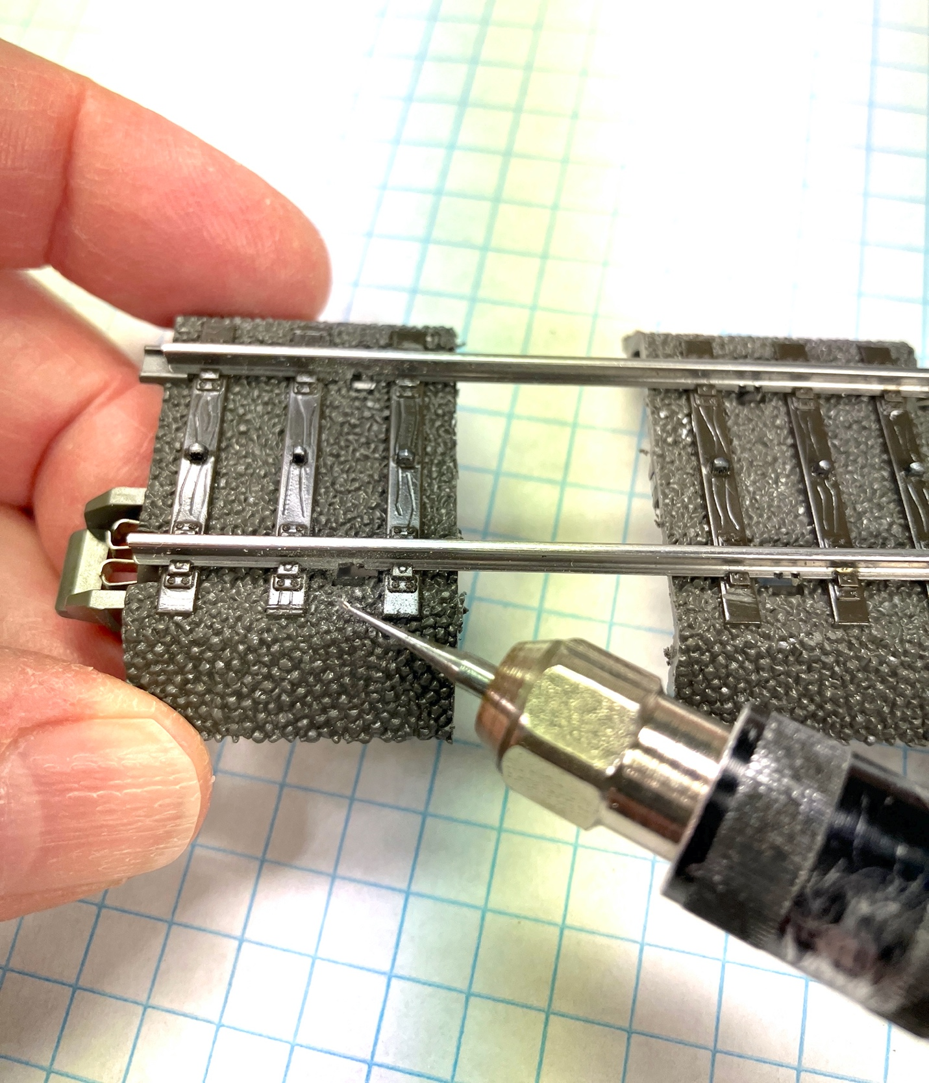

Second step: Cut out the tab burrs with a dental drill

That still was not sufficient to remove all of the burrs, so I cut a narrow piece of 220-grit sandpaper and slid it under the rails.

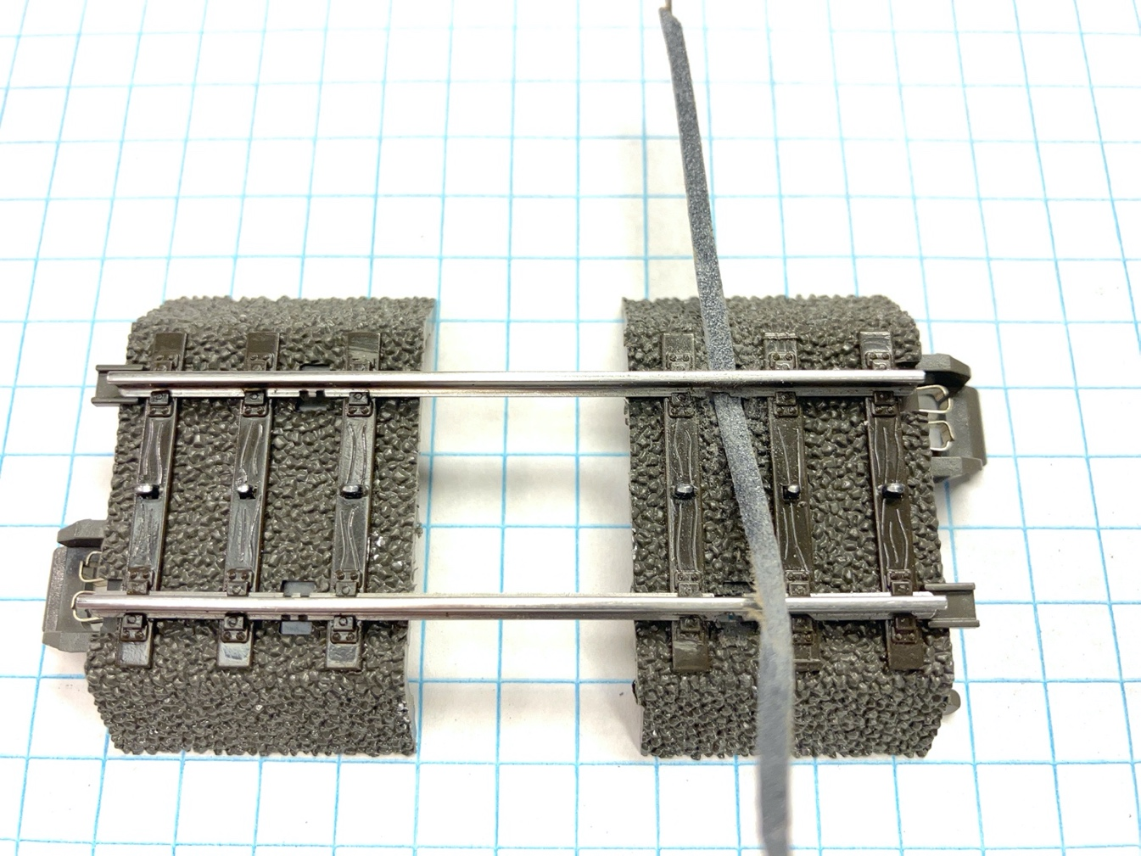

Remove remaining burrs and smooth the underside of the rail

After removing all the burrs from the flange, the Moving section slid smoothly along the rails and met the fixed section.

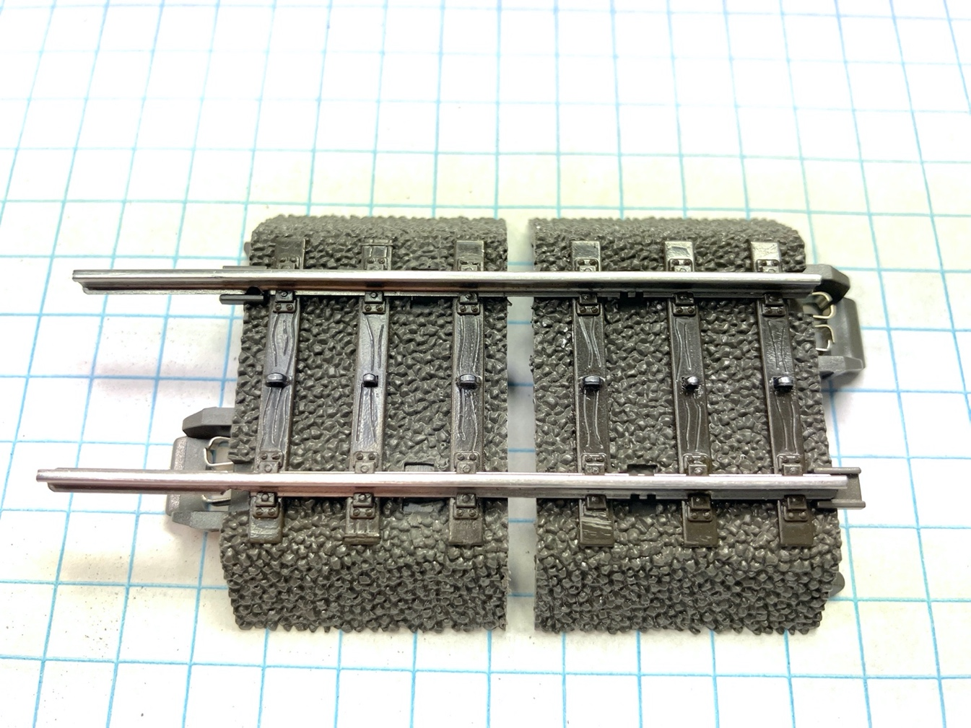

The moving section has been slid over to mate with the fixed section

With the two sections together, I applied AC gel to the joint and clamped them together.

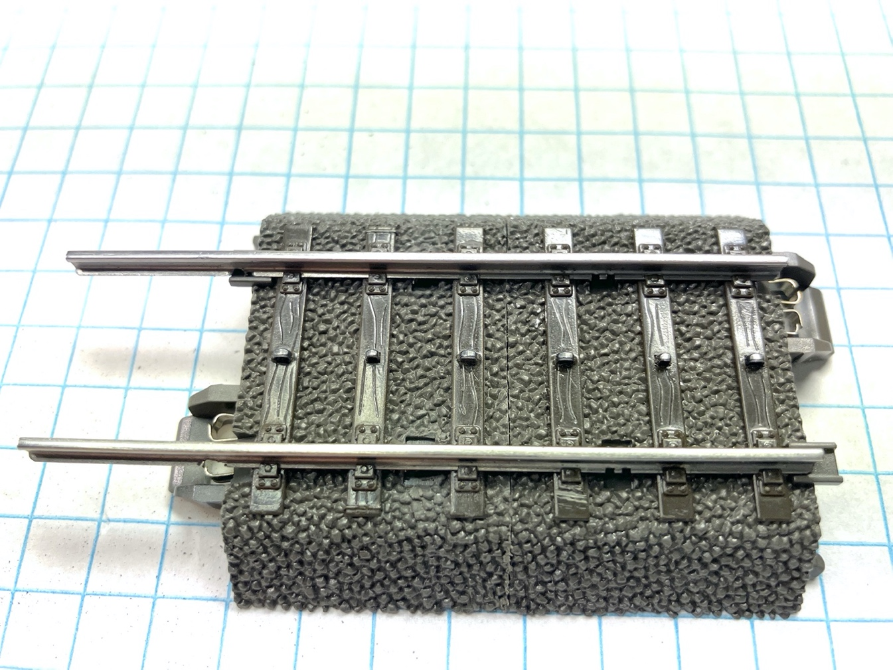

As I had planned, the space between the ties in the cut area was the same as the space between ties in the rest of the track.

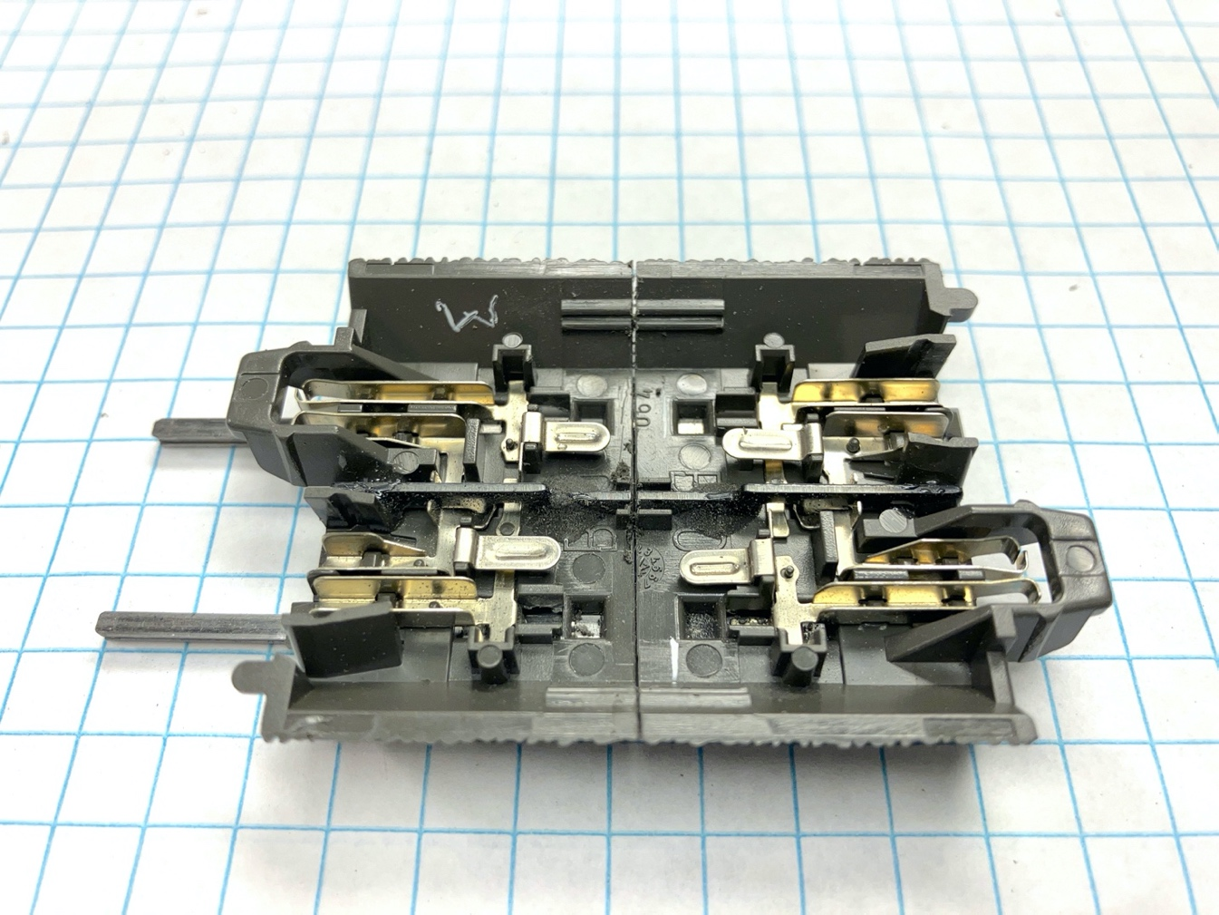

The view from underneath.

Finally, I cut the protruding ends of the rails off with the Dremel disc. Notice that the area of the flange that was cut in the step above, was in the part of the rail that was discarded.

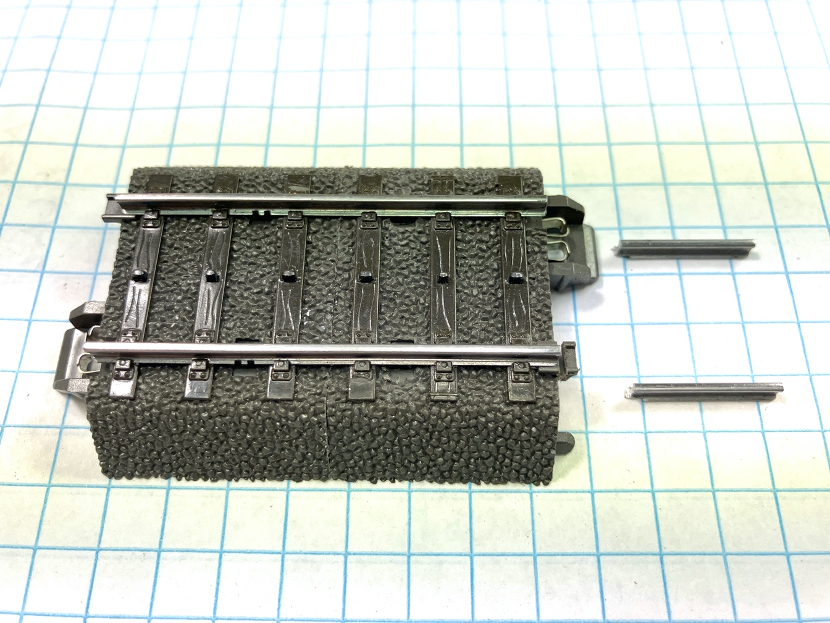

The last operation was to re-establish electrical continuity by soldering wires between the electrical connections.

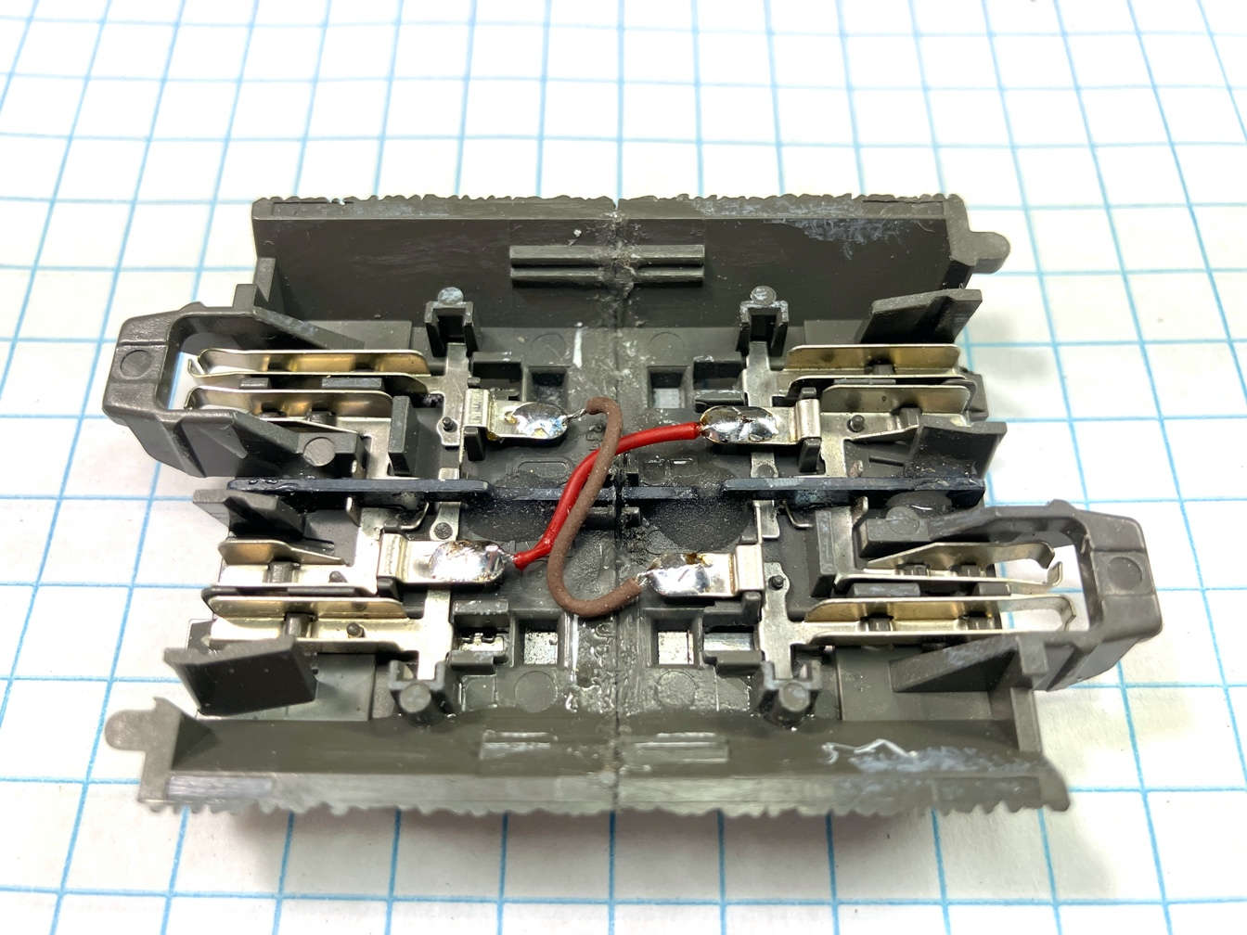

The finished, revised section is 1.6 cm shorter than the 24064, so it's now 4.8 cm, and fits nicely into the track gap on my layout. I believe this technique can be used to adjust the length of any section of C-track.

I want to express my sincere appreciation to Bernhard Watkins for establishing the procedure that I followed, and for providing answers to my questions as I went step-by-step. Although this seemed like a daunting process, Bernhard's logical approach made it easy, and it worked perfectly.