Main Station setup of signals and sensors

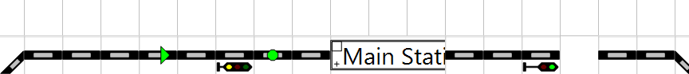

Entry Signal SetUp -

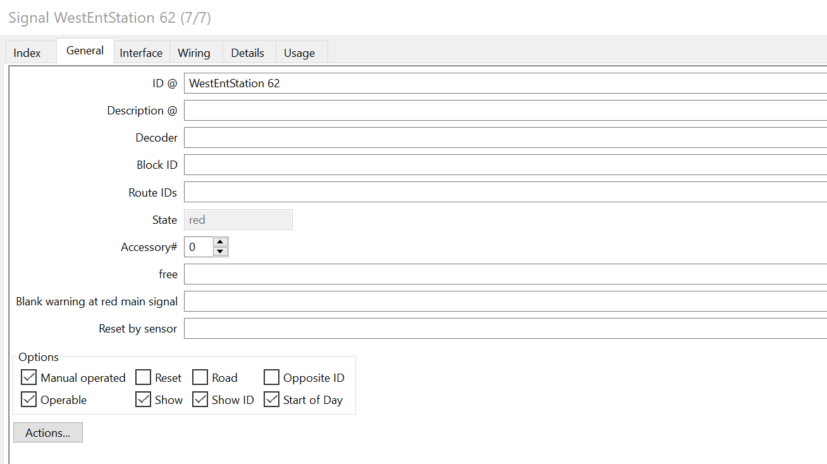

Interface for Signal

Note that Node is left out as Port identifies the address assigned to the signal

Block SetUp Signal WestEndStation 62 is at the + side of the block (left side) (are spaces allowed in the name?)

I have not yet set up blocks for the entire layout. Just starting this process.

Signal Interface tab

Sensor - Circuit track

General Tab

Interface tab

My L88 (in the CS2) has TypeName as LinkS88 (2931) and Device ID 115

I have 2 buses attached to the L88. I confirmed the address (1011) of the sensor from the CS2 Memory screen

Jean advised that I look at the Rocrail Control/Sensor Monitor tab to confirm the sensor is active (within Rocrail) The state changes from 0 to 1 and back to 0 as I click on it. When I run a train over the sensor, the state changes from 0 -1-0 quickly. I assume this means the momentary pulse to the S88 is sent. But the signal does not change (in RocRail or on the layout).