OK….let me try again……..

I am trying to run wiring to this:

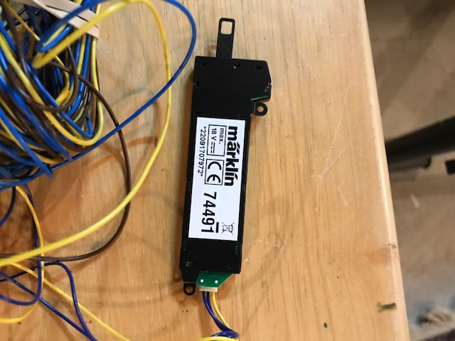

This is the transformer I have:

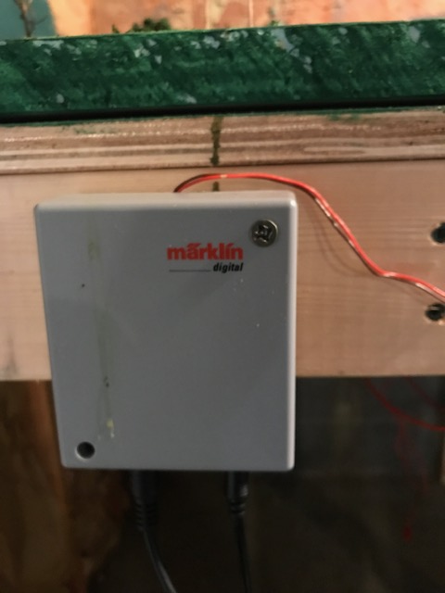

I am using this Control Box:

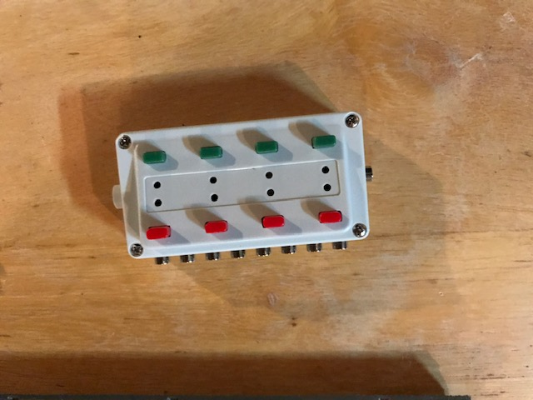

With this power distribution strip:

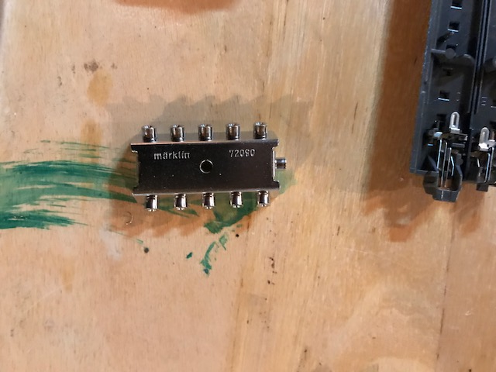

I am now getting power by attaching to a piece of track that is part of my layout ( I have a wire running from the 2 prongs

on the left (or right side ) on the bottom (underside ) of the track.

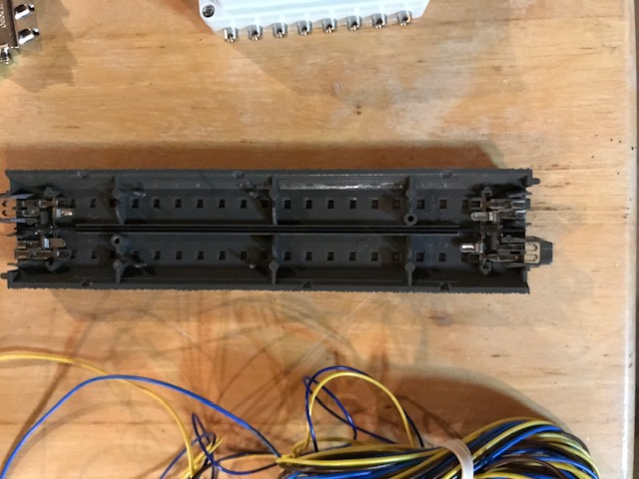

It works fine…

I am now trying to run a second (2nd) control box and following the procedure as above mentioned



When I do this ( try to run a second control box)



The control box:



works. I can control the turnout switches ( see first picture) but the red and green lights that are on the control box



Do not work!

DO I NEED OR CAN I USE AN ADDITIONAL TRANSFORMER (SECOND PICTURE)

TO POWER THE CONTROL BOX WHICH IN TURN OPERATES THE TURNOUT SWITCHES????