THE MARKLIN 7039 SIGNALS
I use the Marklin 7039 Home Signal to drive my Braking Delays.
You could use any signal with a solenoid which switches a current supply on and off.

The Marklin 7039 Home Signal has the following inputs/outputs :
1) Yellow Wire, for providing current to the solenoid
2) Blue Wire, for changing to GREEN signal
3) Blue Wire, for changing to RED signal
4) Red Wire, normally for Track Current input from live track
5) Red Wire, normally for Track Current output to isolated track
6) Brown Socket at front, for grounding the current for the light bulb
7) Grey Socket at back, for Catenary Current input from live catenary
8) Grey Socket at back, for Catenary Current output to isolated catenary

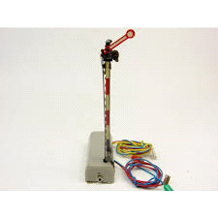

THE BRAKING MODULE
The Braking Module has the following inputs/outputs :
1) RED Track connector, for connect to the live track "B"
2) BROWN Track connector, for connecting to the ground track "O"
3) GREEN wire, for connecting to the Transition Section
4) YELLOW wire, for connecting to the Braking Section
5) ORANGE wire, for connecting to the Stop Section
6) RED wire, for connecting to the 12v DC +ve current
7) DIODE/BLACK wire, for connecting to the 12v DC -ve current
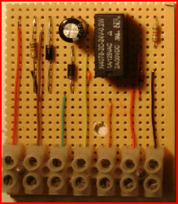

CONNECTING THE SIGNALS TO YOUR CONTROLLER
Connect the signals in whichever way you normally choose for the signals to change Red/Green.
You will do this by connecting the Signal Yellow/Blue/Blue wires to your normal controller.
Operating options include operated from the Central Station / Mobile Station / Keyboard / Button controller.
Diagrams for connecting the signals could be these , or could be k83 boxes.
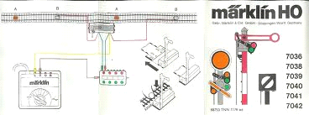

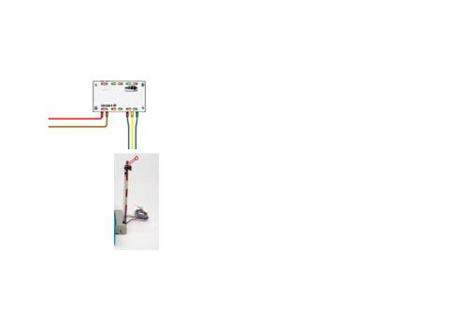

DO NOT CONNECT THE SIGNAL RED CURRENT WIRES AT THIS STAGE !!

CONNECTING THE POWER SOURCE FOR THE BRAKING MODULES
The Braking Module contains a Relay which requires a 12v DC Power Source.
The Signal will be switched on or off to activate the Braking Module. We shall use the solenoid from the Marklin 7039 Signal to switch the Relay on and off by using the RED wires from the Marklin 7039 Home Signal connected to the 12v DC Power.
So, the connections must be :
1) The 12v DC current +ve must be connected to the Braking Module input (RED wire).
2) The Braking Module output (DIODE/BLACK) must be connected to the signal RED wire input.
3) The signal RED wire output must be connected to the 12v DC current –ve.

Be sure to follow this diagram carefully :
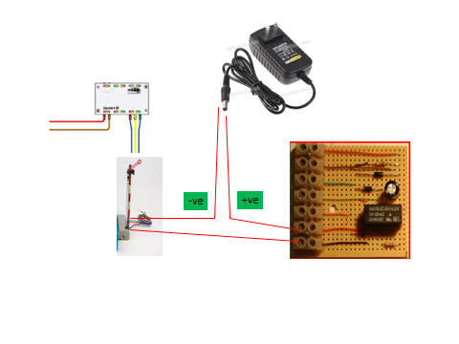
You should hear the Braking Module Rely "click" every time when you switch the signal on and off.Test this !!
The signal solenoid acts as your switch to switch the Braking Module on and off.

CONNECTING THE LIVE TRACK CURRENT TO THE BRAKING MODULE
Connect the RED and BROWN wires from a live section of track to the Braking Module.
The diagram is as follows :
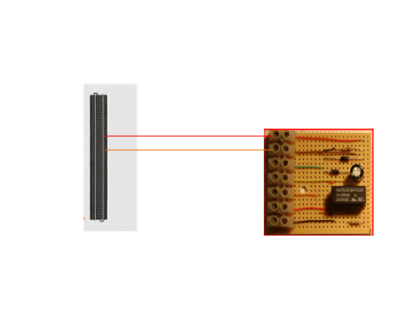

ISOLATED TRACK SECTIONS
The Braking Module requires you to isolate 3 sections of track. Use the Marklin Isolators to separate the "B" sections of track.
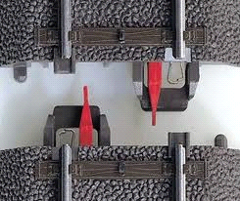
You must have 3 adjacent sections of track with no turn-outs / double slip / joins in the combined 3 sections of track. The "O" sections of track can be continuous for the wheels to be grounded over the entire braking module so no isolators are required here.
The 3 isolated sections of track are called :
1) Transition Section
2) Braking Section
3) Stop Section
The Transition Section is normally half a length of track. Its purpose is to separate the live track from the braking track.
The Braking Section needs to be about 5 track lengths for most locomotives to slow down at the station. Try to keep the Braking tracks all the same length so that the trains slow down and reach the end of the Braking Section each time.
The Stop Section is normally half length of track. Its purpose is to stop the train if the train drives right through the Braking Track.
The best result is achieved when the train slows down and stops in the Braking Section. The train should not continue through the Braking Section and stop in the Stop Section because it will come to a sudden jolting halt, which is not what the Braking Module intends to do. The Stop Section is only there to prevent the train from continuing if it is going too fast through the Braking Section.

CONNECTING THE BRAKING MODULE TO THE ISOLATED SECTIONS
Connect the Braking Module as per the following diagram :
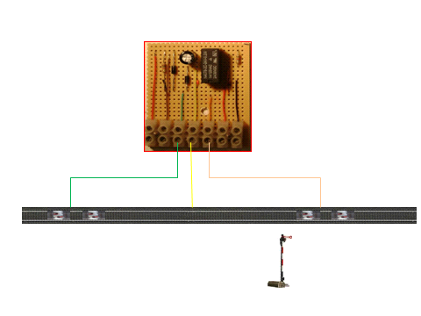
The three isolated sections are :
- Transition Section
- Braking Section
- Stop Section
The connectors are made to the live current (RED) or also known as “B”.

The Ground Current to the wheels “O” continues throughout all of these sections.

ALTERNATE BRAKING MODULE : TRAINS APPROACHING FROM BOTH SIDES
If you have a situation where trains could approach the station area from both sides, and you want the Braking Module to work independently of whichever direction the train approaches, then you can use the alternate format of the Braking Module.
In this situation, we shall require :
1) Transition Section
2) Braking Section
3) Transition Section
Connect the wire from the Braking Module Transition Section to both of the Transition Sections on both sides of the Braking Section.
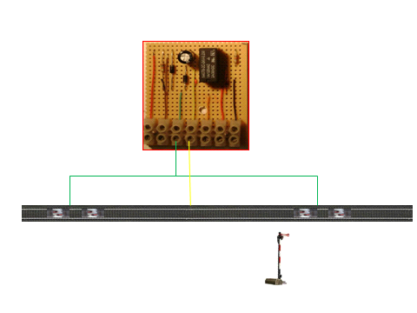

Note that under this arrangement, there is no wire connected to the Stop Section on the Braking Module. If the train runs through the Braking Section, it will enter the next Transition Section and automatically increase speed again.

SETTING THE BRAKING DELAY ON YOUR MARKLIN LOCOMOTIVES
Programming the Braking Delay on your Marklin locomotives is done using your Central Station / Mobile Station / 6021 Controller.
I usually set it to maximum Braking Delay and maximum Acceleration Delay.

SENDING COMMANDS TO THE TRAINS WHILE THEY ARE IN THE BRAKING MODULE
You cannot send commands to trains which are in the braking module while the signal is RED. The trains will continue to operate the functions in operation while it has stopped at the station, but the train will not react to new commands.
If the signal is GREEN, then obviously the train will react to new commands in the braking module.

CONNECTING SEVERAL SIGNALS TO THE POWER SOURCE
You can connect several signals to the 12v DC Power source, but they must be connected in Parallel and not in Series. Obviously if they are in Series, then one signal in the off position will set all signals off.

MARKLIN USERS NET
http://www.marklin-users.net/forum/yaf_postst30717_comparing-prices-for-home-made-braking-module.aspx#post448468

WARNING-1
Do not have any turnouts / double-slips in your end-to-end braking modules. These will cause a short-circuit on your system. If you have to have them, you must have a Transition section break between any live track and the braking module track.

WARNING-2
Do not run trains with 2 x pickup sliders which could possibly cause a short circuit between the sections of track. For example, a train with a slider and a wagon with a slider next to each other could possibly cause a short circuit when the current from the live section flows through the first slider to the transition track and then through the second slider to the braking module.

WARNING-3
Do NOT connect the Signal Red Current wires to the track, as you probably normally do !
They will be used for another purpose - to switch the Braking Module Relay on and off.

